TITLE: AtlantECO [WP2] – Traditional microscopy dataset – Ostracoda abundance and biomass concentration data
______________________________________________________________

1.- INTRODUCTION
This dataset contains 133 533 georeferenced abundance and biomass records of 13 accepted scientific names of Ostracoda of various taxonomic levels. This dataset is a compilation of the following three main global and regional datasets that reported abundances of marine planktonic ostracods:
- The Coastal & Oceanic Plankton Ecology, Production & Observation Database (NMFS-COPEPOD, O’Brien, 2014) from the National Oceanic and Atmospheric Administration - https://www.st.nmfs.noaa.gov/copepod/atlas/html/taxatlas_4211000.html
- The Southern Ocean CPR (SO-CPR) survey (Hosie, 2021) - doi:10.26179/ksds-s610
- The Australian CPR (AusCPR) survey (AusCPR) - https://catalogue-imos.aodn.org.au/geonetwork/srv/eng/catalog.search#/metadata/c1344e70-480e-0993-e044-00144f7bc0f4

2.- METHODOLOGY USED
The datasets listed above were first downloaded and re-formatted to the common AtlantECO WP2 data format. To homogenize the taxonomic classification of all the AtlantECO WP2 datasets containing microbiome (i.e., plankton) diversity data, the species names of each dataset were automatically compared to the list of species names accepted in the World Register of Marine Species (WoRMS), using the ‘worms’ R package version 0.2.2 (Holstein, 2018). Typos, synonyms and deprecated species names were corrected and the unique numerical identifiers of each accepted scientific name (i.e., AphiaID) were provided as well. Then, the datasets were progressively combined in as follows.

First, the NMFS-COPEPOD ostracod records (n = 26 735) were used as a basis since it corresponds to the most widely used compilation of historic zooplankton records. 1 362 records were removed because they were associated with missing abundance values (total n records = 25 373). Older CPR records present in NMFS-COPEPOD were kept as the available data from the North Atlantic and North Pacific CPR survey (Richardson et al., 2006) did not contain ostracod records. Second, we added the 51 717 abundance records from the SO-CPR survey. No records were removed because of missing abundance values (total n records = 77 090). Third, we added the 56 448 ostracod abundance records from the AusCPR survey. A single record was removed because it was associated with a missing abundance value, and four others were discarded because they exhibited a missing maximum sampling depth (‘MaxDepth’) value (total n records = 133 533).

The cleaned abundance sheet were passed through the following stages of processing to reach the final data set files.
- The taxonomy of the individual carbon values was checked against WoRMS. Individual carbon values are individual carbon content measurements and Mean/Median/Min/Max/Stdev estimates (in mgC.ind-1). For Ostracoda, 3 individual carbon content measurements derived from the following sources were compiled from Kiørboe, T. (2013). Zooplankton body composition. Limnology and oceanography, 58(5), 1843-1850. doi:https://doi.org/10.4319/lo.2013.58.5.1843. These values can be found on sheet 3 of “AtlantECO-BASEv1_dataset_Ostracoda_ind_carbon_values_20220930.xlsx”. This is also done for the field observations in the abundance sheet.
- The life form variable gives information of the type of population organization- and the ecological organization of the organism recorded (e.g."singular","colonial","symbiotic","free living" etc.). As data is taken from different sources, the ‘LifeForm’ entries show a range of different information and formats. All the life form entries within the abundance sheet and individual carbon values are standardized by subdividing the information in more detailed variables; Life Form Phase, Stage Name, Stage Number, Life form Min Size and Sex.
- The unit of which the field observation is measured in it standardized. All entries in #/m2 are converted to #/m3. This is done by dividing the MeasurementValue (numeric value of the measurement ie. Concentration) by the difference between maximum and minimum depth (MeasurementValue /(MaxDepth – MinDepth)).
- To calculate biomass concentrations, estimates of individual carbon content at the most precise taxonomic resolution possible (i.e., species-level mean carbon content to convert a species-level abundance observations) were determined. We took the highest known taxonomic classification of the observation and match it to the individual carbon content values. When there was no immediate match, we worked up the taxonomic ranking until a match is found. For example, for an observation identified down to the species level, Conchoecissa imbricata, no associated individual carbon content values are found until the Family level (Halocyprididae). Therefore, it is matched with all individual carbon content values that have family Halocyprididae. In this instance the mean carbon mass calculated for this observation is composed of 2 different individual carbon content values. The minimum (Min) and maximum (Max) carbon mass is the lowest and highest values that we used to compute the mean (Mean) and its standard deviation (Stdev). When additional information of life form attributes is known, of either minimum size, phase, larval stage name, larval stage number and/or sex, it is considered when looking for matches. In some instances, the highest classification is to group level, which is an arbitrary name we assigned to functional groups to organize data sheets. When this occurs all individual carbon content values are averaged.
- Each abundance record was converted to minimum, maximum and mean carbon biomass concentration (‘MinBiomass’, ‘MaxBiomass’ and ‘MeanBiomass’, respectively) expressed in mgC.m-3 based on estimates minimum, maximum and mean individual carbon content (‘MinBiomassConversion’, ‘MaxBiomassConversion’ and ‘MeanBiomassConversion’, respectively) expressed in mgC.ind-1.
- Then the biomass concentrations of sampling events were summed. A sample event is defined by the Latitude, Longitude, Event Date, Depth, Year, Month and Day. This produces the total biomass concentration of all organisms of that specific event. The average biomass value was taken of organisms that had multiple replications at a sample event to avoid increase in biomass due to sampling replication.
- The summed biomasses are rasterized by latitude, longitude and depth levels (WOA Depth Levels). As the depth levels do not have even intervals, spatial cubes of different y lengths are produced. Then to produce 1 lat x 1 long x 122 depth x 12 month dimensions the mean biomass per month over all the years is taken per 1 x 1 x 122. The minimum biomass is (MinBiomass) therefore comes from the month with the lowest value and the maximum biomass (MaxBiomass) is the month with the highest value.

The main R packages used to implement ZooBase v2 were: ‘rlang’ version 1.0.6 (Henley and Wickham, 2022), ‘fst’ version 0.9.8 (Klik, 2022), ‘writexl version 1.4.0 (Ooms and McNamara, 2021), ‘reshape2’ version 1.4.4 (Wickham, 2020), ‘RNetCDF’ version 2.5-2 (Michna and Woods, 2022), ‘lubridate’ version 1.8.0, (Grolemund and Wickham, 2011), ‘progress’ version 1.2.2 (Csárdi, 2018), ‘units’ version 0.7-2 (Pebesma et al. 2016), ‘stringr’ version 1.4.1 (Wickham, 2022), ‘tidytable’ version 0.9.0 (Fairbanks et al., 2022), ‘readxl’ version 1.4.1 (Wickam and Bryan, 2022), ‘worms’ version 0.4.4 (Chamberlain and Bart, 2022) and ‘taxize’ version 0.9.100 (Chamberlain et al., 2022).

3.- DATASET DESCRIPTION
Data type: Abundances converted to biomass concentrations.
Latitude/Longitude format: WGS 84 (-180°E/+180°E).
Geographic area covered by the dataset: Global Ocean.
Depth range covered by the dataset: From 0m to 4911m.
Time period covered by the dataset: From 09-07-1938 to 31-01-2021.
Dataset format: .csv file with semicolon-delimited columns.
Date of dataset creation: 20/12/2022.
Raw dataset repository: AtlantECO’s GeoNode (https://atlanteco-geonode.eu/).

4.- MAIN VARIABLE DESCRIPTION
MeasurementTypeID: Has not been defined within AtlantECO
MeasurementValue: Organisms concentration (i.e., abundance) in ind.m-3
MeasurementID: Has not been defined within AtlantECO
occurrenceID; Combination of decimalLatitude, decimalLongitude, Day, Month, Year, MaxDepth, ScientificName, MeasurementValue, MeasurementUnit.

5.- DATA OVERVIEW
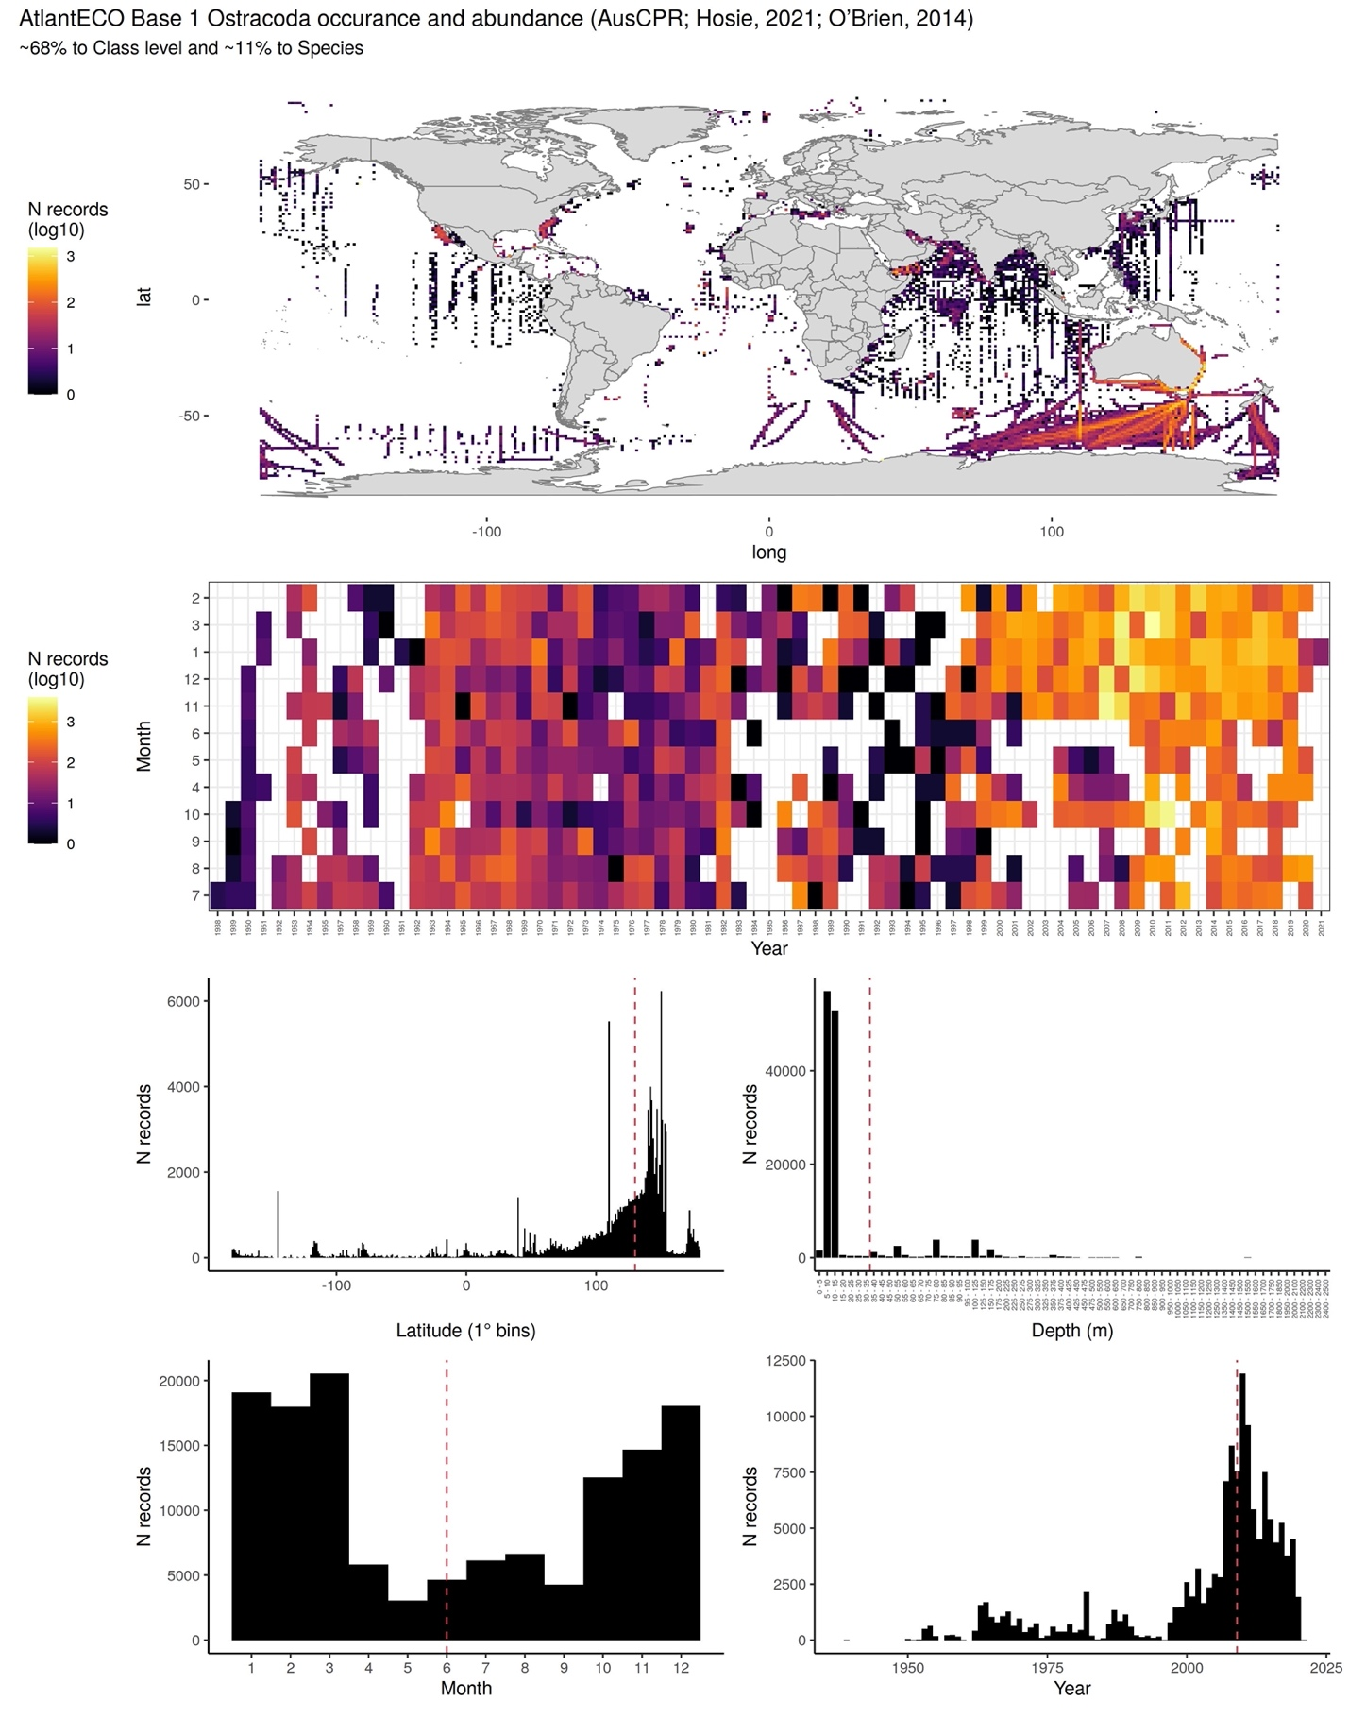

6.- CONTRIBUTORS
- Fabio Benedetti (fabio.benedetti@usys.ethz.ch), ETH Zürich, Switzerland.
- Ruby Bader (ruby.bader@usys.ethz.ch), ETH Zürich, Switzerland.
- Meike Vogt (meike.vogt@usys.ethz.ch), ETH Zürich, Switzerland.

