TITLE: AtlantECO [WP2] – UVP5 casts dataset – Zooplankton major groups (abundance, biovolume and biomass; Imaging)

1.- INTRODUCTION
This dataset is based on UVP casts performed at 37 sampling stations around the Vitória Trindade Seamount Chain (Brazil), during “Ilhas” cruise. Data on abundance, biovolume and biomass of zooplankton are provided, and images obtained in the casts can be accessed in EcoTaxa platform (Project “Uvp5_sn200_ilhas_2017_filtered_vignettes”).

2.- METHODOLOGY USED
The Ilhas cruise took place onboard the RV Alpha Crucis in the summer of 2017 (from January 27 to February 16). Zooplankton images were recorded in situ in vertical profiles performed in different depths, using a UVP5 (Picheral et al., 2010). The maximum sampling depth varied from 45 and 2894 m. A total of 197803 images (> 600 µm) were acquired, uploaded to EcoTaxa (https://ecotaxa.obs-vlfr.fr/; Lombard et al., 2019; Picheral et al., 2017) and sorted into zooplankton major groups. The number of occurrences of zooplankton major groups (Rhizaria, Cnidaria, Polychaeta, Copepoda, Eumalacostraca, Ostracoda, Echinodermata, Chaetognatha and Ctenophora) was recorded by 5-m depth to calculate the abundance (ind.m⁻³). The individual biovolume of organisms was measured based on the cross-sectional area of images (Drago et al., 2022):
$\frac{4}{3} . π.{\left(\frac{ESD}{2}\right)}^{3 }$ with $ESD=2.\sqrt{Area/π}$

The individual biomass of organisms was calculated based on specific allometric equations that also used the cross-sectional area and biovolume of zooplankton (Beers et al., 1970; Michaels et al., 1995; Marcolin et al. 2015 (a compiled from Beers (1966), Hernández‐León and Montero, (2006), Davis and Wiebe (1985)). The biovolume (mm³.m⁻³) and biomass (µg C m⁻³) were estimated per taxa by 5-m depth for each sampling station. Figures with the most abundant groups can be find below.

3.- DATASET DESCRIPTION
Data type: abundance (ind.m⁻³), biovolume (mm³.m⁻³) and biomass (µg C m⁻³) of zooplankton.
Latitude/Longitude format: WGS 84 (-180°E/+180°E).
Geographic area covered by the dataset: Western South Atlantic (19°- 21°S and 28°- 38°W).
Depth range covered by the dataset: From 0 to 2894 m.
Time period covered by the datase t: From 27-01-2017 to 16-02-2017.
Dataset format: .xlsx file.
Date of dataset creation: 14-09-2022.
Raw dataset repository: Zenodo.

4.- MAIN VARIABLE DESCRIPTION
MeasurementTypeID: Has not been defined within AtlantECO.
MeasurementValue: abundance (ind.m⁻³), biovolume (mm³.m⁻³) and biomass (µg C m⁻³).
MeasurementID: Has not been defined within AtlantECO
occurrenceID: Combination of decimalLatitude, decimalLongitude, Day, Month, Year, Depth, MinDepth, MaxDepth, ScientificName, MeasurementValue.

5.- CONTRIBUTORS
- Gleice de Souza Santos (gleicesantos@usp.br)
- Rubens Mendes Lopes (rubens@usp.br)
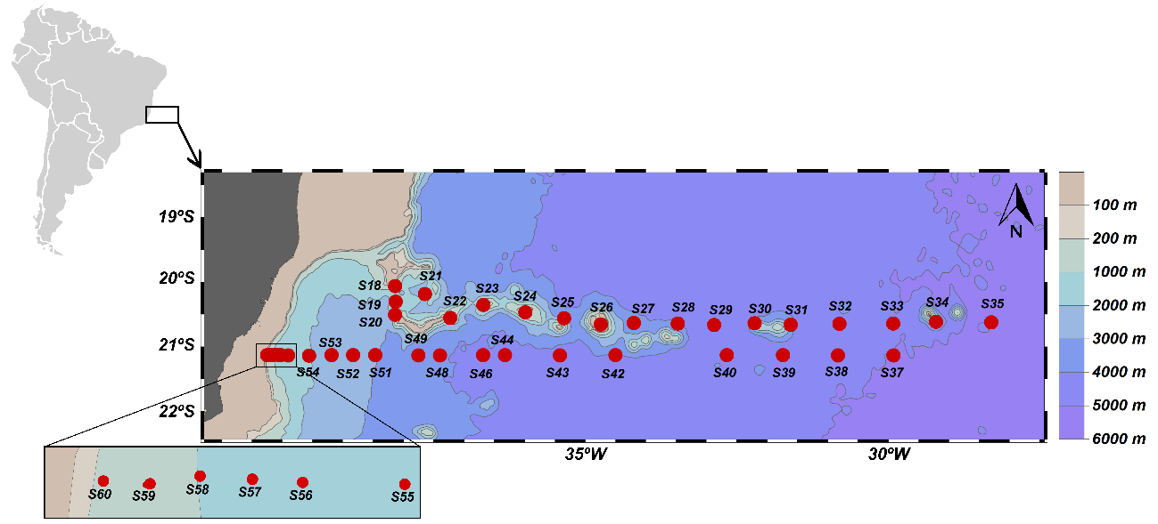

Figure 1 - Sampling stations along the Vitória Trindade Seamount Chain (Western South Atlantic).

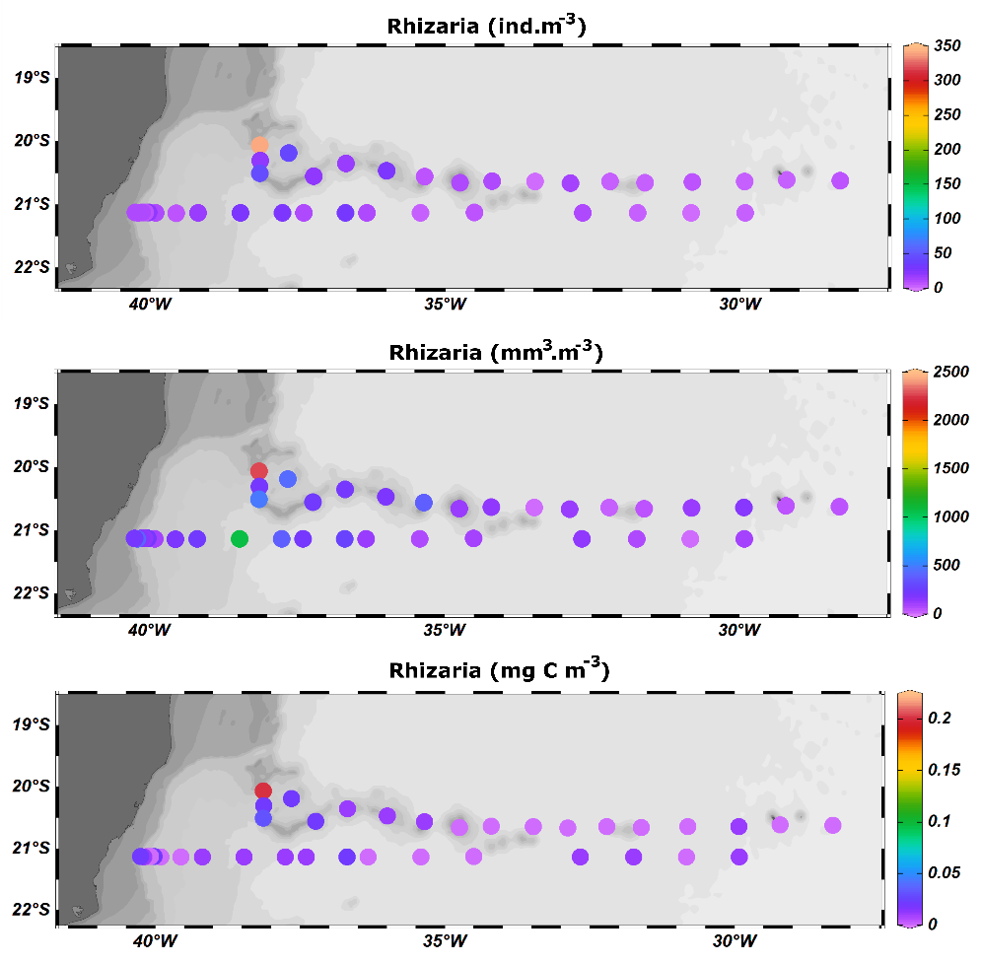

Figure 2 – Means of abundance, biovolume and biomass of Rhizaria in the first 150 m of depth.

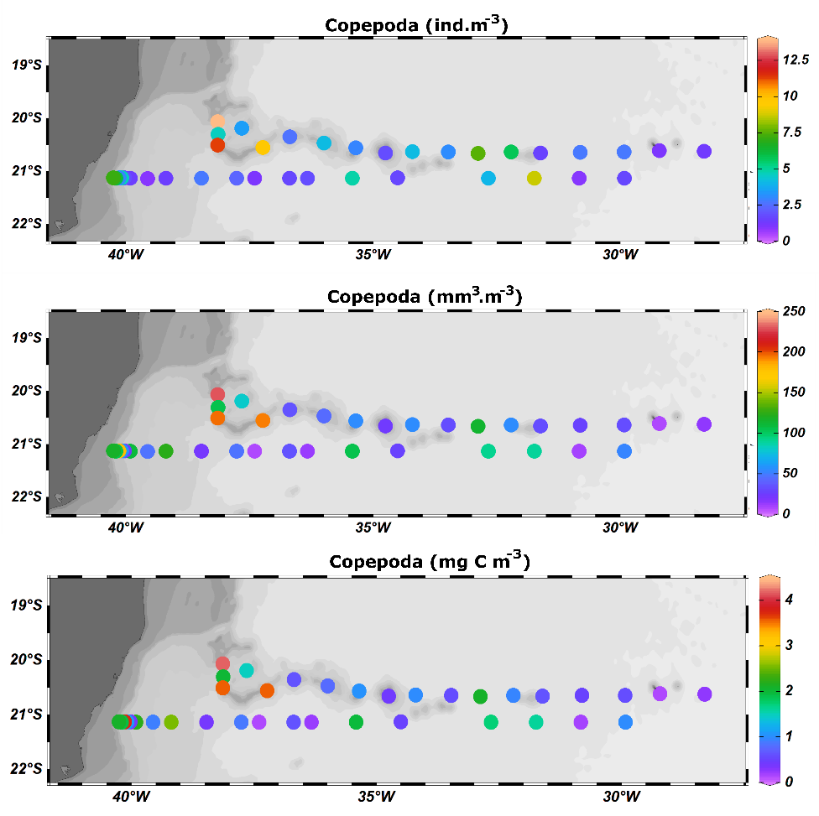

Figure 3 – Means of abundance, biovolume and biomass of Copepoda in the first 150 m of.

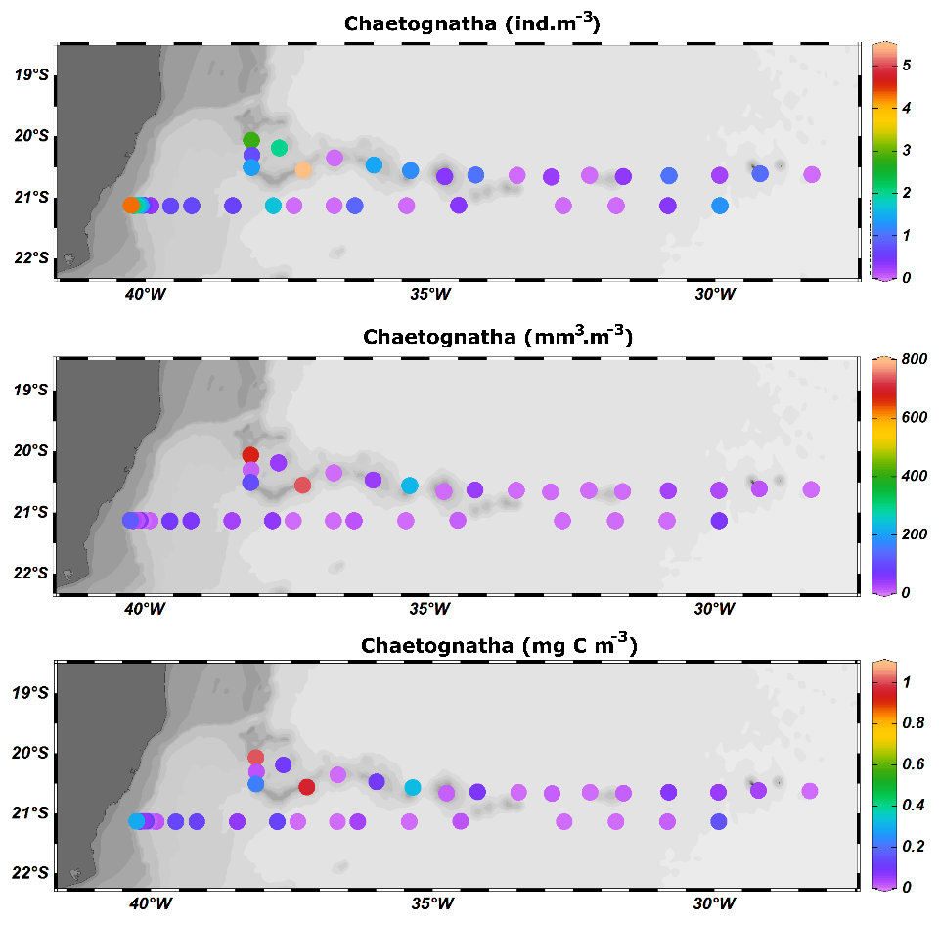

Figure 4 – Means of abundance, biovolume and biomass of Chaetegnatha in the first 150 m of depth.
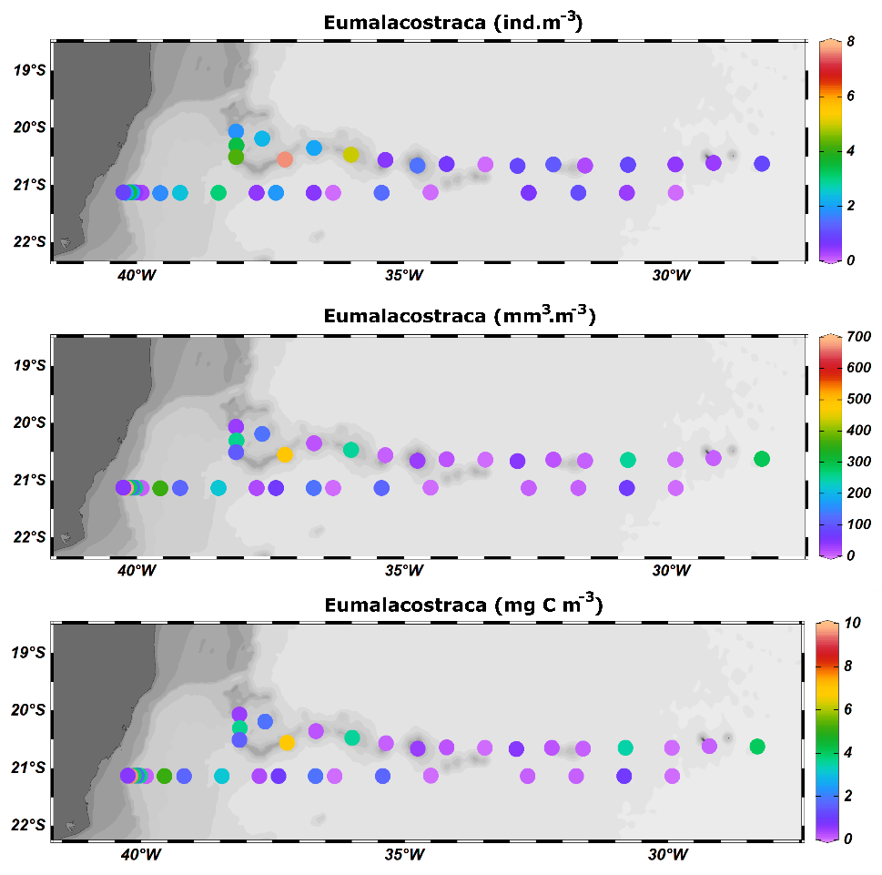

Figure 5 – Means of abundance, biovolume and biomass of Eumalacostraca in the first 150 m of depth.

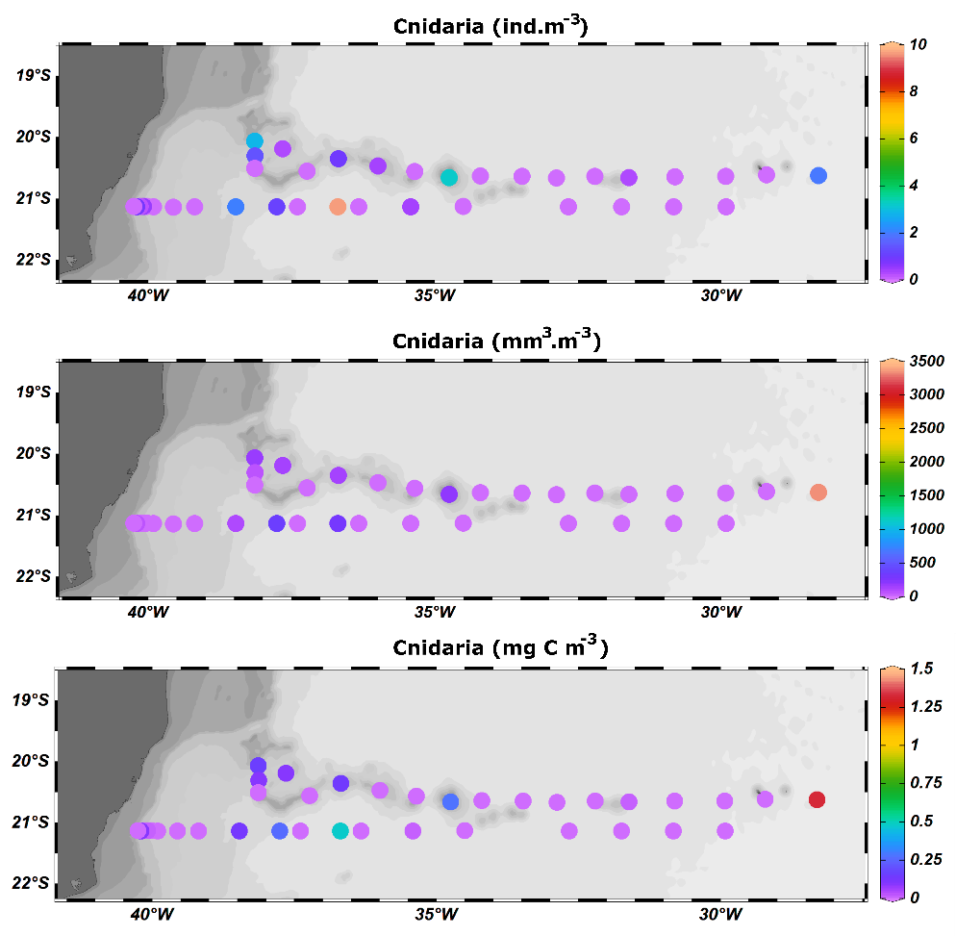

Figure 6 – Means of abundance, biovolume and biomass of Cnidaria in the first 150 m of depth.
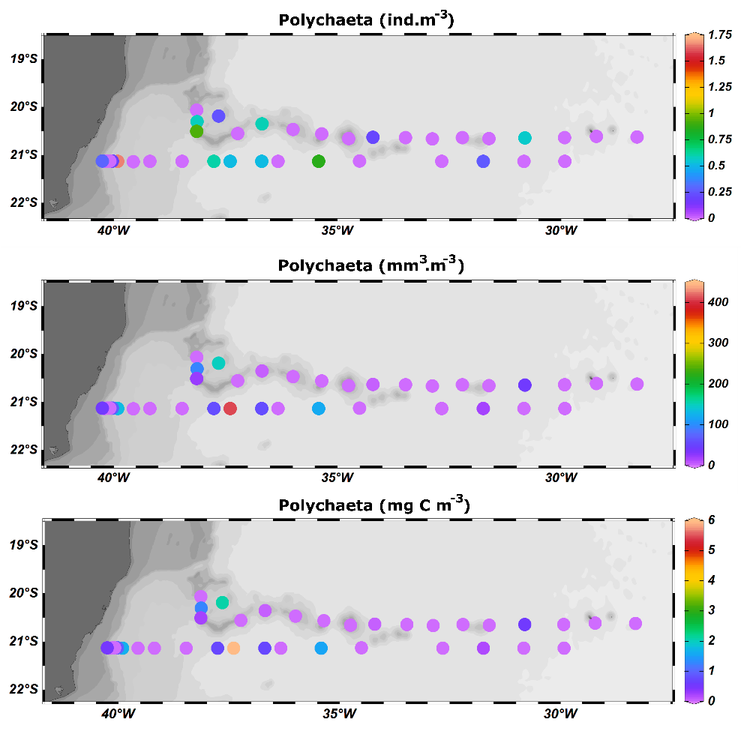

Figure 7 – Means of abundance, biovolume and biomass of Polychaeta in the first 150 m of depth.

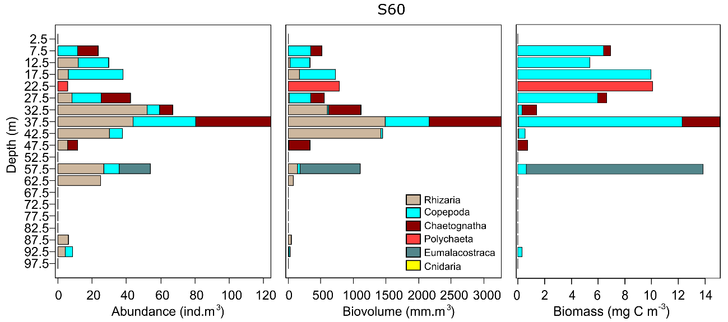
Figure 8 – Vertical profiles of abundance, biovolume and biomass of zooplankton major groups at the station S60.

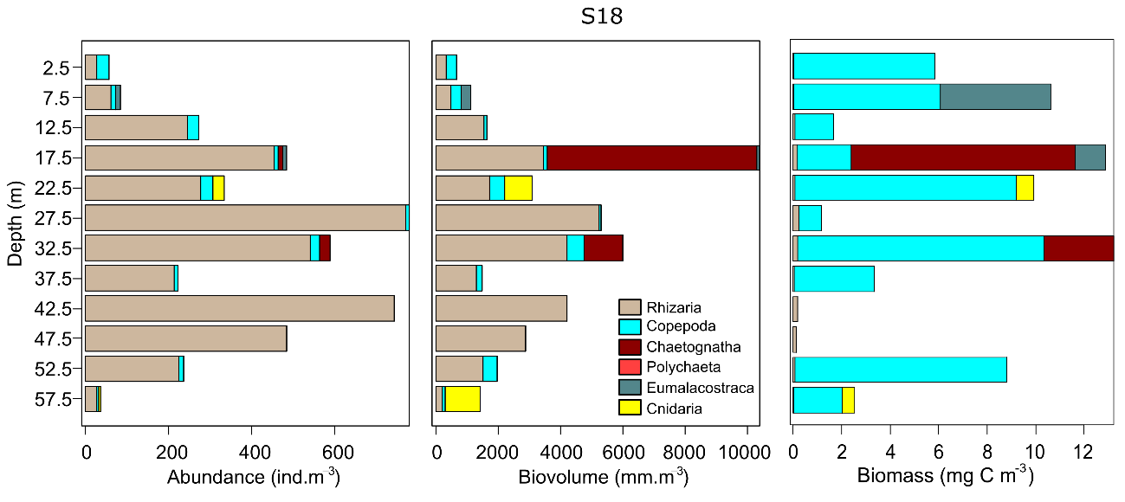
Figure 9 – Vertical profiles of abundance, biovolume and biomass of zooplankton major groups at the station S18.

6.-REFERENCES

Beers, J. R. (1966) Studies on the chemical composition of the major zooplankton groups in the Sargasso Seas off Bermuda. Limnology and Oceanography, 11, 520–528. https://doi.org/10.4319/lo.1966.11.4.0520.

Beers, J. R., Stewart, G. L. (1970) in The Ecology of the Plankton off La Jolla, California, in the Period April through September, 1967, Part VI (eds Strickland, J. D. H., Solarzano, L. & Eppley, R. W.) Bulletin of the Scripps Institution of Oceanography, 17, 67–87.

Davis, C. S., Wiebe, P. H. (1985) Macrozooplankton biomass in a warm-core gulf stream ring: Time series changes in size structure, taxonomic composition, and vertical distribution. Journal of Geophysical Research, 90, 8871–8874. https://doi.org/10.1029/JC090iC05p08871.

Drago, L., Panaïotis, T., Irisson, J. O., Babin, M., Biard, T., Carlotti, F., ... & Kiko, R. (2022). Global Distribution of Zooplankton Biomass Estimated by In Situ Imaging and Machine Learning. Frontiers in Marine Science, 9. https://doi.org/10.3389/fmars.2022.894372.

Hernández‐León, S., Montero, I. (2006) Zooplankton biomass estimated from digitalized images in Antarctic waters: A calibration exercise. Journal of Geophysical Research: Oceans, 111(C5). https://doi.org/10.1029/2005JC002887.

Lombard, F., Boss, E., Waite, A. M., Uitz, J., Stemmann, L., Sosik, H. M., Schulz, J., Romagnan, J. B., Picheral, M., Pearlman, J., Ohman, M. D., Niehoff, B., Möller, K. O., Miloslavich, P., Lara-Lopez, A., Kudela, R. M., Lopes, R. M., Karp-Boss, L., Kiko, R., … Appeltans, W. (2019) Globally consistent quantitative observations of planktonic ecosystems. Frontiers in Marine Science. https://doi.org/10.3389/fmars.2019.00196.

Marcolin, C. R., Gaeta, S., Lopes, R. M. (2015). Seasonal and interannual variability of zooplankton vertical distribution and biomass size spectra off Ubatuba, Brazil. Journal of Plankton Research, 37(4), 808-819. https://doi.org/10.1093/plankt/fbv035.

Michaels, A. F., Caron, D. A., Swanberg, N. R., Howse, F. A., Michaels, C. M. (1995) Planktonic sarcodines (Acantharia, Radiolaria, Foraminifera) in surface waters near Bermuda: abundance, biomass and vertical flux. Journal of Plankton Research, 17(1):131-163. https://doi.org/10.1093/plankt/17.1.131.

Picheral, M., Guidi, L., Stemmann, L., Karl, D. M., Iddaoud, G., & Gorsky, G. (2010) The underwater vision profiler 5: An advanced instrument for high spatial resolution studies of particle size spectra and zooplankton. Limnology and Oceanography: Methods, 8:462–473. https://doi.org/10.4319/lom.2010.8.462.

Picheral, M., Colin, S., & Irisson, J. O. (2017) EcoTaxa, a tool for the taxonomic classification of images. https://ecotaxa.obs-vlfr.fr.

