_______________________________________________________________

TITLE: AtlantECO [WP2] - cflux dataset – size spectra
______________________________________________________________

1.- INTRODUCTION
This table contains size spectra data derived from the 5th version of the Underwater Vision Profiler (UVP5), for a total of 2.083.352 observations (or size spectra).

2.- METHODOLOGY USED
Data were collected from a public database (PANGAEA) which already assembled and cleaned the entire dataset. We then processed those data using R (version 4.1.2).

3.- DATASET DESCRIPTION
Data type: Absolute values of particle counts for 27 class sizes (#/L)
Latitude/Longitude format: WGS84 (-180°/+180°)
Geographic area covered by the dataset: Global Ocean
Depth range covered by the dataset: From 2.5 to 6017.5 m
Time period covered by the dataset: from 2008-06-19 to 2020-11-23
Dataset format: comma separated (.CSV file)
Date of dataset creation: 2022-09-12
Raw dataset repository: ETHZ server

4.- MAIN VARIABLE DESCRIPTION
MeasurementTypeID: source of the data (only UVP5)
MeasurementValue: particle counts for 27 size bins.
MeasurementID: Sample_id which is unique for every UVP5 vertical profile.

5.- LINKS
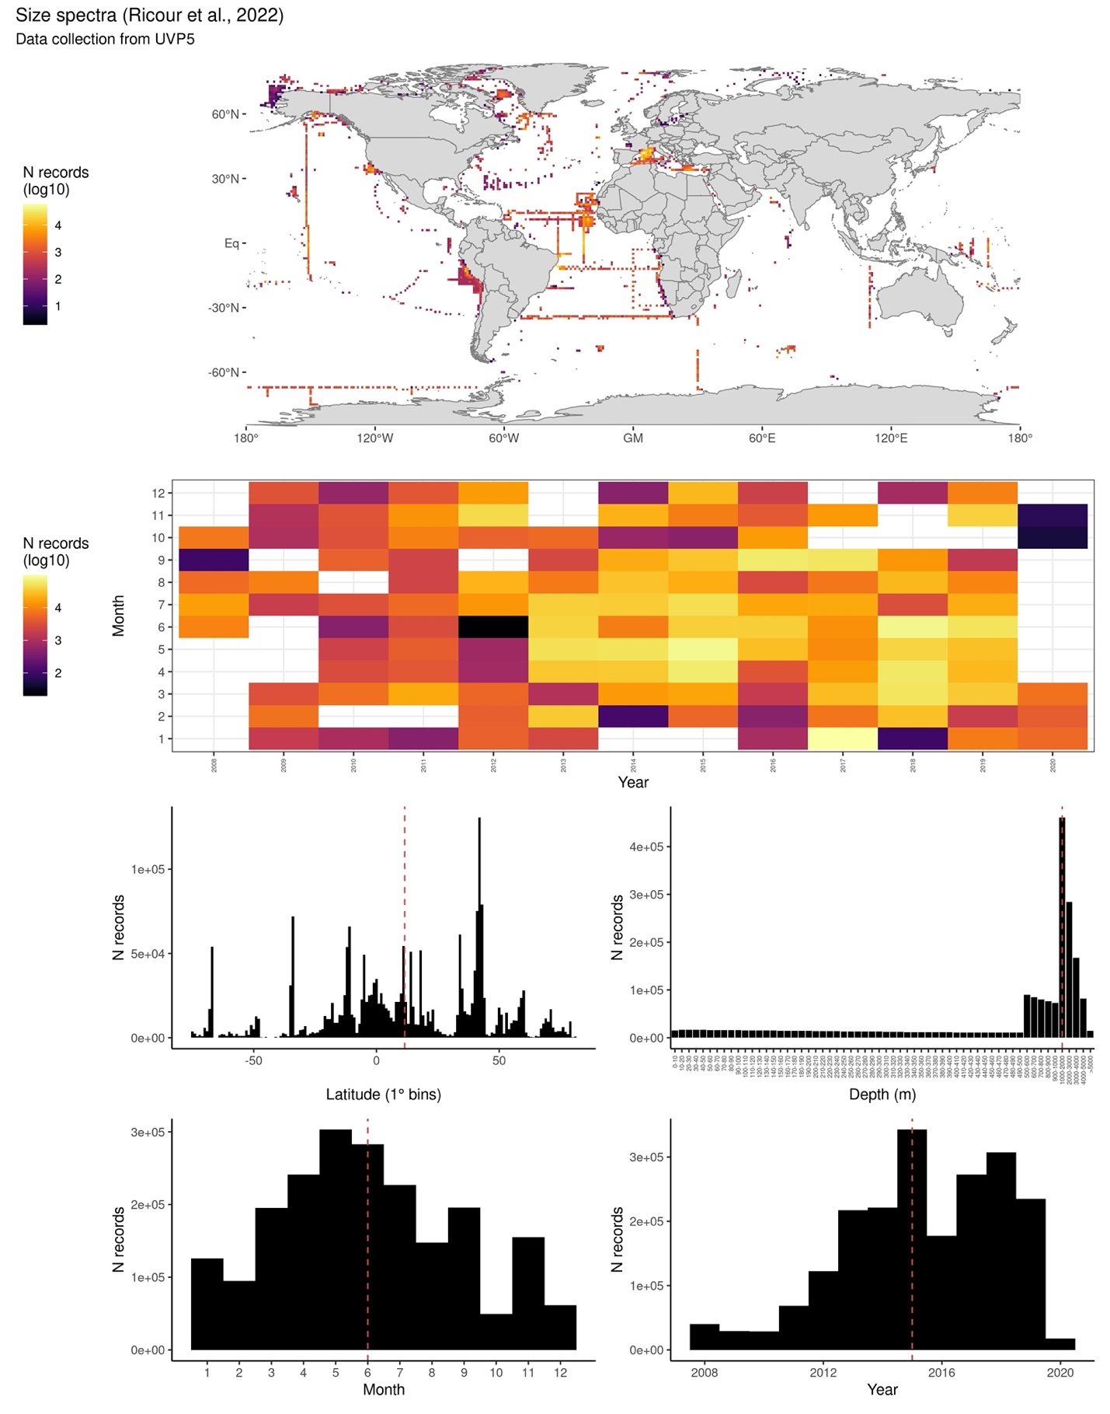

6.- CONTRIBUTORS
Guidi Lionel – Oceanographic Laboratory of Villefranche-sur-Mer – France - lionel.guidi@imev-mer.fr
Ricour Florian - Oceanographic Laboratory of Villefranche-sur-Mer - France – florian.ricour@uliege.be

