_______________________________________________________________

TITLE: AtlantECO [WP2] - cflux dataset – carbon fluxes
______________________________________________________________

1.- INTRODUCTION
This table contains carbon fluxes data derived from sediment traps and from concentration deficits of the 234 Thorium isotope (15.425 observations).

2.- METHODOLOGY USED
Data were collected from public databases (PANGAEA) and were processed (assembled, cleaned from missing values and/or duplicates) using R (version 4.1.2).

3.- DATASET DESCRIPTION
Data type: Absolute values of carbon fluxes (mgC/m²/day)
Latitude/Longitude format: WGS84 (-180°/+180°)
Geographic area covered by the dataset: Global Ocean
Depth range covered by the dataset: 5-5847 m
Time period covered by the dataset: meters from 1976-07-04 to 2018-08-27
Dataset format: comma separated (.CSV file)
Date of dataset creation: 2022-09-12
Raw dataset repository: ETHZ server

4.- MAIN VARIABLE DESCRIPTION
MeasurementTypeID: source of the data (either sediment traps or Thorium 234)
MeasurementValue: carbon flux in mgC/m²/day
MeasurementID: Not defined in AtlantECO

5.- LINKS
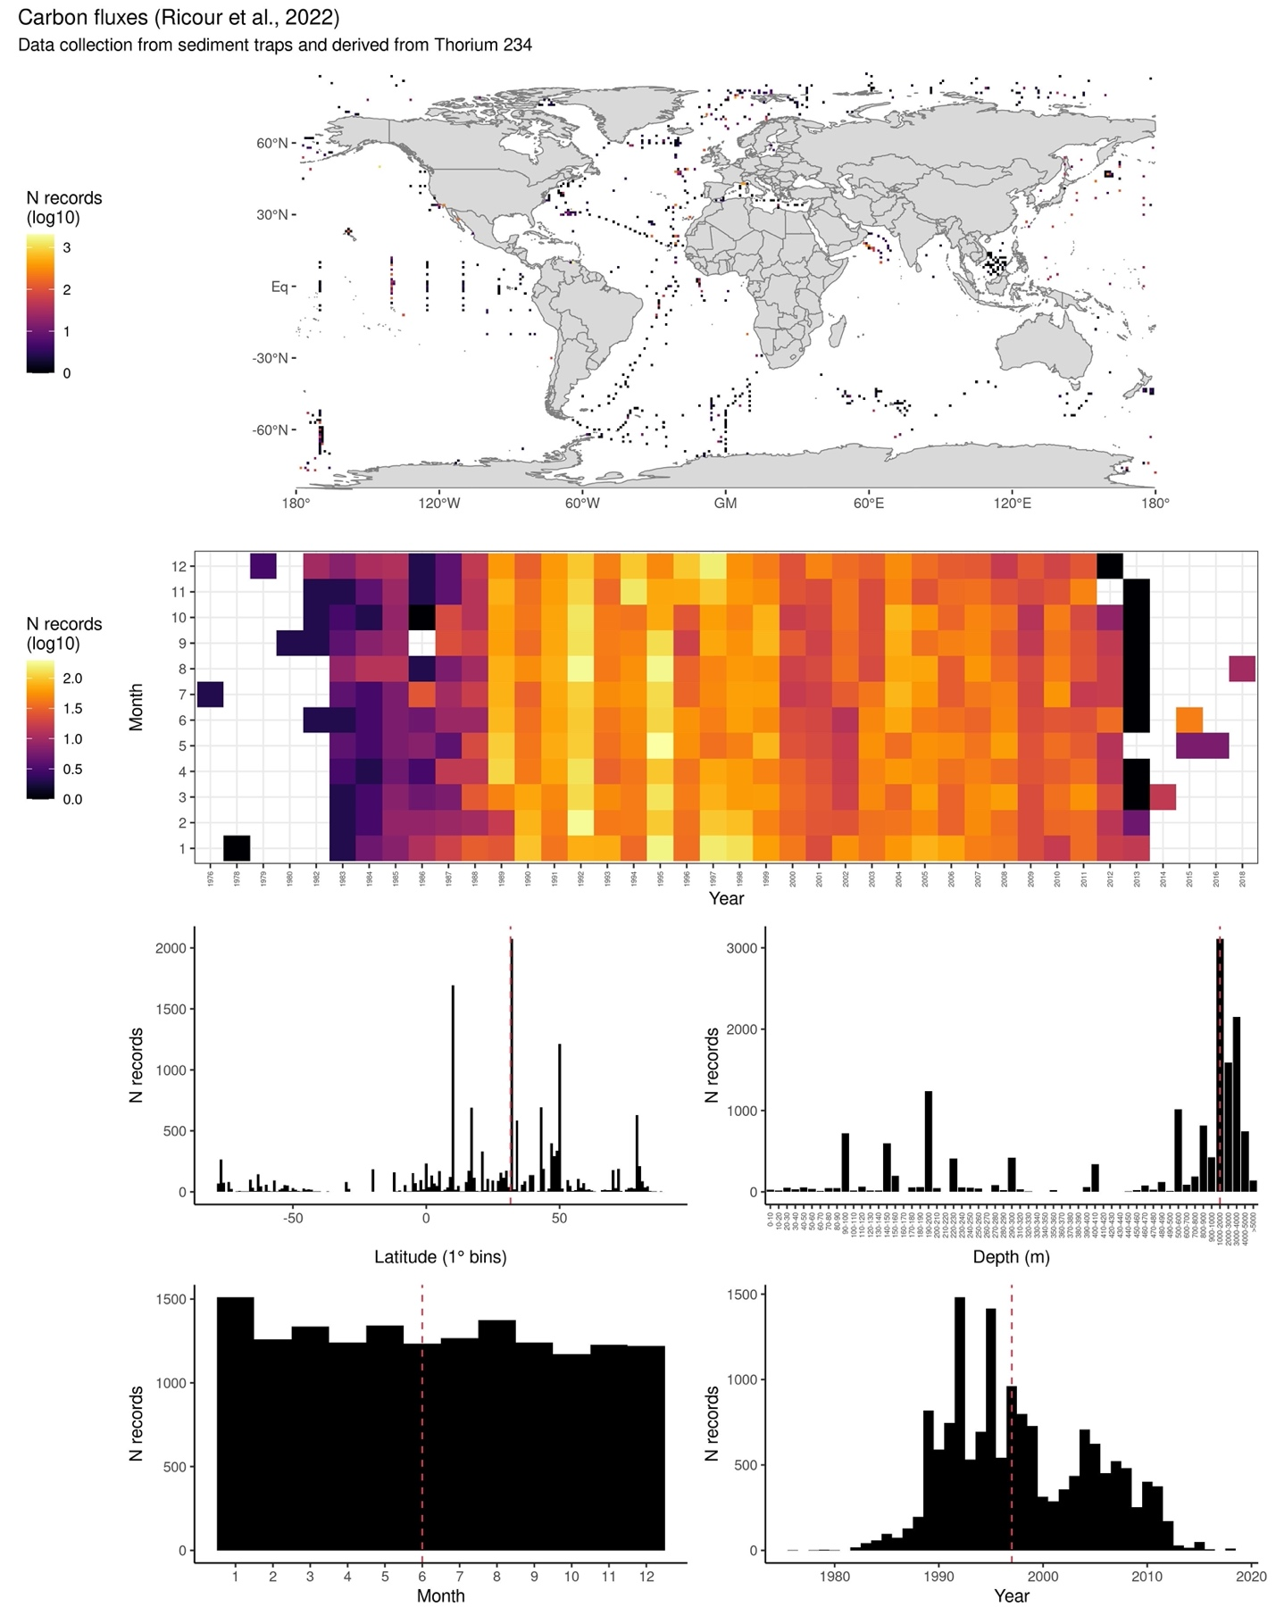
6.- CONTRIBUTORS
Guidi Lionel – Oceanographic Laboratory of Villefranche-sur-Mer – France - lionel.guidi@imev-mer.fr
Ricour Florian - Oceanographic Laboratory of Villefranche-sur-Mer - France – florian.ricour@uliege.be

